Programming Assignment Unit 2

University of the People

CS 2203 Databases 1

Naeem Ahmed, instructor

September 14, 2022

Programming Assignment Unit 2

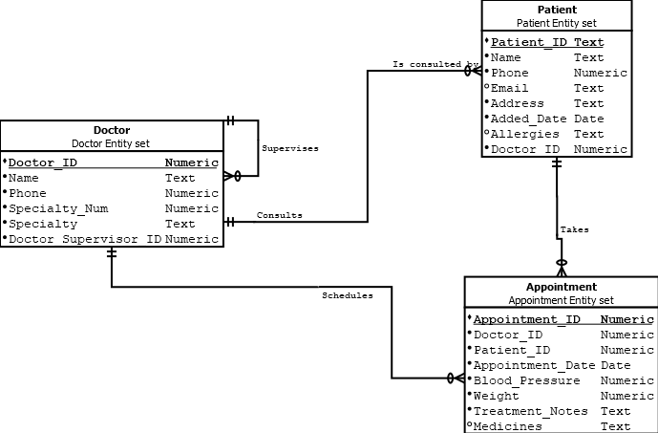

**Entity set:** Doctor

**Primary key:** Doctor_ID

**Candidate key:** Name, Phone, Specialty_Num, Doctor_Supervisor_ID

**Relation Degree:** 6

**Entity set:** Patient

**Primary key:** Patient_ID

**Candidate key:** Name, Phone, Address

**Relation Degree:** 8

**Entity set:** Appointment

**Primary key:** Appointment_ID

**Candidate key:** Doctor_ID, Patient_ID, Appointment_Date

**Relation Degree:** 8